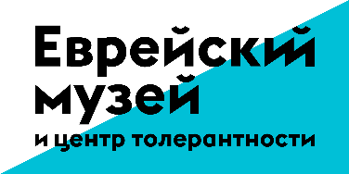
The Jewish Museum and Tolerance Center and the Museum of the Jewish History in Russia present the exhibition
"Freedom for All? The History of One People in the Years of Revolution"
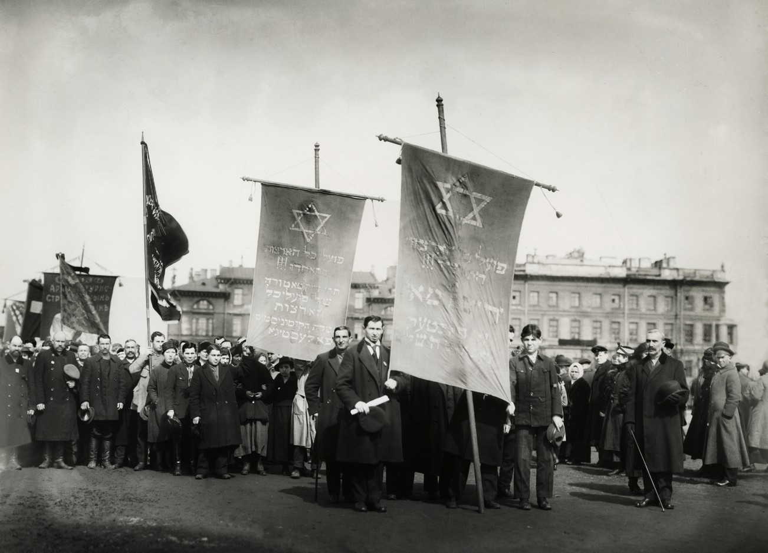
Unknown author
Jewish organisations during the May Day Demonstration on Marsovo Pole (Field of Mars) in Petrograd. 1919

October 17, 2017 - January 14, 2018
On October 17, 2017, the Jewish Museum and Tolerance Center will open the exhibition "Freedom for All? The History of One People in the Years of Revolution" - a multidisciplinary research project prepared together with the Museum of Jewish History in Russia. The exhibition narrates the cultural, political and religious development of the Jewish community in Russia during the years of the revolution (1917-1919).
It features paintings, photographs, books, theatre posters, leaflets and posters of political parties collected from museums, archives and private collections. The exhibits show the rise and diversity of the Jewish socio-political and artistic life before and after February 1917, the time of freedom, hope and their limitations in 1919. Paintings by Marc Chagall, Robert Falk, Issachar Ber Ryback and El Lissitzky feature among the exhibits. Many paintings and documents presented at the exhibition will be shown for the first time.
The structural basis of the exposition will consist of chronicles of the Jewish history in the context of the Russian revolution prepared by the team of the multimedia documentary project "1917. The Free History". Besides historical facts and statistics, the chronicle features stories from the first-person perspective by the participants of the events such as Lev Trotsky, Yulia Martova, Mark Chagall, Vera Inber, Semeyon Dubnov and Vasily Shulgin. Their stories will sound in the special spaces that express the spirit of the time and convey the character of their biographies as well as the personalities. Visitors of the exhibition will be able to read their letters, hear their voices from old telephones and on the radio.
The wide range of historical materials used to prepare this exhibition reflects the entire diversity of the political and cultural life from 1917 to 1919. The exhibits and design create a feeling of being present and immersed in the atmosphere of the revolutionary times. It introduces a short but significant and rich period of the history of the Jewish community in Russia.

Curators : Grigory Kazovsky, Ekaterina Krylova.
Dates of the exhibition: October 17, 2017 - January 14, 2018

Press inquiries:
Tel .: +7 (495) -645-05-50 ( ext.230 )
+7 916 075 17 18 / Nina Dymshitz
press@jewish-museum.ru
nina.d@jewish-museum.ru

With support of:

In partnership with:

Partner:

