The Jewish Museum and Tolerance Center presents the exhibition of Philippe Halsman: Jump.

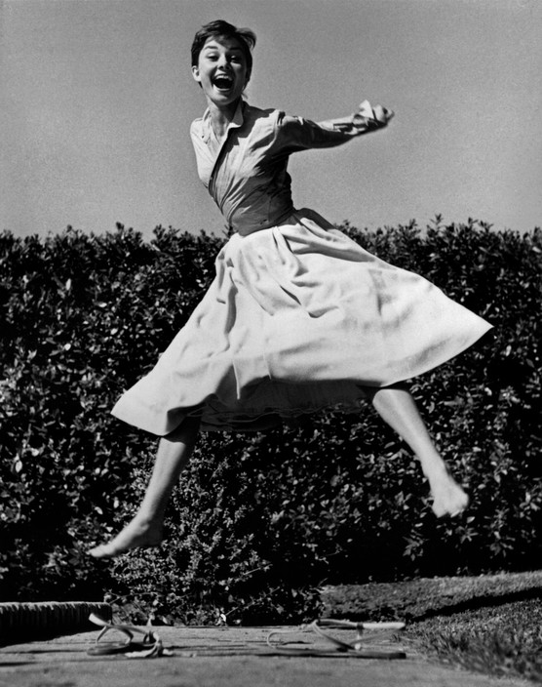
Audrey Hepburn, 1955 © Philippe Halsman / Magnum Photos

February 22 – May 21
Curator: Nina Gomiashvili

As part of the X Moscow International Biennale ‘Fashion and Style in Photography’ the Jewish Museum and Tolerance Center presents the first solo exhibition in Russia of photographer Philippe Halsman: Jump.

“I was motivated by a genuine curiosity. After all, life has taught us to control and disguise our facial expressions, but it has not taught us to control our jumps. I wanted to see famous people reveal in a jump their ambition or their lack of it, their self-importance or their insecurity, and many other traits.”

Philippe Halsman is one of the central figures in American photography of the second half of the 20th century. His insightful portraits of politicians, artists, intellectuals appeared on more than a hundred LIFE magazine covers as well as in Look, Esquire, The Saturday Evening Post, Paris Match. Fifty photographs of Halsman will be displayed at the exhibition including his most known work created with Salvador Dali – Dali Atomicus.

Philippe Halsman was born in Riga in a Jewish family. He studied engineering in Dresden before professionally taking up photography. In the beginning of the 1930s Halsman moved to Paris, the artistic center of the time, and opened his own photo studio there. In Paris Halsman started to get published in magazines. His photographs were published in Vogue, Vu and Voilà. He made portraits of André Malraux, Paul Valéry, Marc Chagall, André Gide, Le Corbusier using his self-designed 4x5 twin-lens reflex camera.

In 1940 Philippe Halsman was already one of the most famous portrait photographers in France. However, when the Nazis occupied Paris, Halsman was forced to leave the country and move to the USA with help of Albert Einstein (whose portrait he would make only seven years later).

Philippe Halsman became immediately popular in America. He made advertising campaigns for Elizabeth Arden Fashion House and from 1942 he began to collaborate with iconic LIFE magazine. Throughout the next 30 years Philippe Halsman created journalistic stories and covers featuring the most important events of America’s life.

In the beginning of the 1950s Halsman took the first photographs from his series which would be later simply and concisely named Jump. Now the Jump series is most often identified with the name of the photographer. He asked his subjects to jump after every portrait session. He explained his unconventional request in the following way: ‘when a person jumps, his attention is mostly directed toward the act of jumping and the mask falls so that the real person appears’.

Among those who jumped are: the family of Henry Ford, Duke and Duchess of Windsor, Marilyn Monroe, Grace Kelly, Richard Nixon, Marc Chagall, Dean Martin and Jerry Lewis, Audrey Hepburn, Sophia Loren, Muhammad Ali and many others. In 1959 Philippe Halsman published the Jump Book which became a classic in photo art.

Exhibition partner:

Financial partner:

For more information please contact:
Nina Dymshits
+7 916 075 17 18
nina.d@jewish-museum.ru

