The Jewish Museum and Tolerance Center present the exhibition project: Upon Request. The Russian Avant-Garde Collection of the Regional Museums. Part II

A.M. Rodchenko. Lines on Green. 1919. Canvas, oil. Kirov Regional Museum of Local Lore, Vyatka Art Museum named after V.M. and A.M. Vasnetsov. Kirov

March 29 – May 28, 2016
The Jewish Museum and the Encyclopedia of the Russian Avant-garde present the sequel of the major exhibition project curated by Andrey Sarabyanov; it is the unique collection from the regional museums of 17 cities: Arkhangelsk, Astrakhan, Vyatka, Ekaterinburg, Ivanovo, Kostroma, Krasnodar, Nizhny Novgorod, Nizhny Tagil, Omsk, Samara, Saratov, Smolensk, Tula, Cheboksary, Yaroslavl, and Yaransk.

This exposition is the follow-up of the first exhibition held at the Museum in spring 2016. It covers the period from 1917 to the beginning of the 1930s – a period when such artistic styles as Cezannism, Cubo-Futurism, Primitivism, which had appeared in the 1910s, were evolving and such new styles as Non-objectivity and Constructivism appeared.

The generation of young artists appeared on the Avant-garde scene; they had graduated from Higher Art and Technical Studios in Moscow and were schooled by the most influential maîtres, mainly, the representatives of the Jack of Diamonds. It was time when the students started to shape the future of new art. They all worked within figurative art and developed such new Avant-garde styles as Expressionism and Surrealism. In the meantime, the schools of the acknowledged masters of the non-objective Avant-garde were founded – Kazimir Malevich’s one in Vytebsk and Michael Matyushin’s one in Petrograg-Leningrad. Alexander Rodchenko also gathered a group of young representatives of Non-objectivity and emerging Constructivism.

For the second exhibition the Jewish Museum and Tolerance Center selected more than 100 works of the acknowledged classics of the Avant-garde: Wassily Kandinsky, El Lissitzky, Michael Matyushin, Lubov Popova, Alexander Rodchenko, Pavel Filonov, and less known artists: Michael Menkov, Yakov Pain, Roman Semashkevitch, Lyudmila Shmidt-Ryzhova, Valentin Yustitsky and others.

The exhibition is based on the research materials of the three-volume Encyclopedia of the Russian Avant-garde.

Media partners:
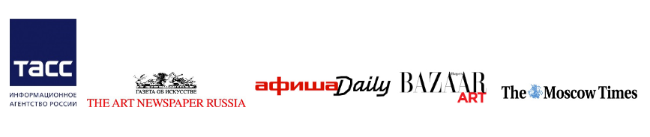

The project is supported by the entrepreneur and founder of the SAFMAR Charitable Foundation M.S. Gutseriev.

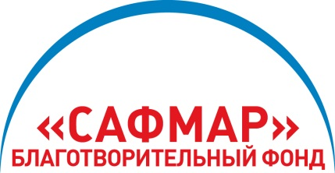

SAFMAR Charitable Foundation is one of the largest non-commercial charity organizations in Russia. The founder of the fund is AO NK RussNeft headed by Mikhail Gutseriev, a famous Russian entrepreneur and art patron.
SAFMAR Charitable Foundation is founded to bring to life socially important long lasting projects in culture, art, education and spiritual development. The Foundation program corresponds to the criteria of transparence, strategical precision and consistency of realization. SAFMAR relies on the best traditions of the Russian practices in the sphere of philanthropy. The Foundation supports several large-scale charity projects together with many famous educational, scientific, museum and NGOs of Russia.

