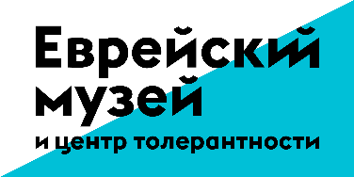

The Jewish Museum and Tolerance Center and the State Tretyakov Gallery present the exhibition “El Lissitzky”.
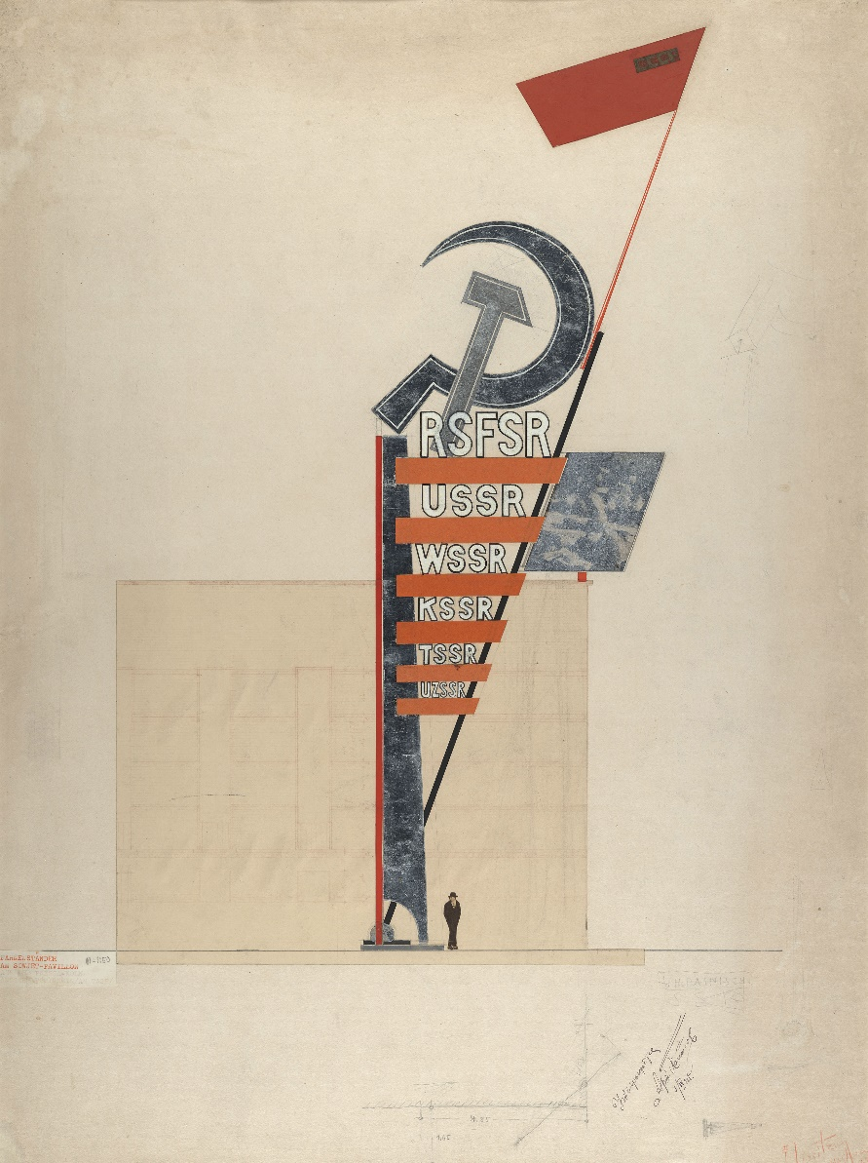

The exhibition "El Lissitzky" is the major retrospective of the artist in Russia and a joint project of the Jewish Museum and Tolerance Center the State Tretyakov Gallery.
El Lissitzky is one of the leading artists of Russian and European avant-garde. He predestined the development of architecture and design in the XX century and invented a new art movement he called "prouns" (literally meaning designs for the confirmation of the new).
The exhibition consists of two parts and takes place in two venues at the same time – in the New Tretyakov Gallery and the Jewish Museum and Tolerance Center. The visitors will see around 400 artworks from the collections of the Tretyakov Gallery, foreign museums and private collections. The exhibition "El Lissitzky" reconstructs the artist's creative path, paying attention to all its stages and different directions.
The early "pre-avantgarde" Lissitzky's period is connected with his work in the Kultur Lige (Jewish cultural and public organization). The artworks of this time will be exhibited in the Jewish Museum and the Tolerance Center. The exposition will also present prouns, figurines, book illustrations, posters, photo collages and photographs.
The Tretyakov Gallery will expose the prouns and architectural projects, sketches of the exhibition design and photographs from the collection of the Tretyakov Gallery. Prouns from the Western collections will be shown for the first time in Russia. The exposition brings together around 200 works from around the world including the Basel Art Museum, the Moritzburg Art Gallery (Halle, Germany), the Van Abbe Museum (Eindhoven, Holland), the Stedelijk Museum (Amsterdam), the Pompidou Center (Paris) and the National Museum of Art Of Azerbaijan of R. Mustafayeva.
Two parts of the exhibition will disclose Lisitsky as a multifaceted painter, book graphic artist, designer, architect, printer and photographer.

