The Jewish Museum and Tolerance Center with support of SAFMAR Charitable Foundation represents the exhibition: Sholem Aleichem. The writer and his characters in art, theater and movies
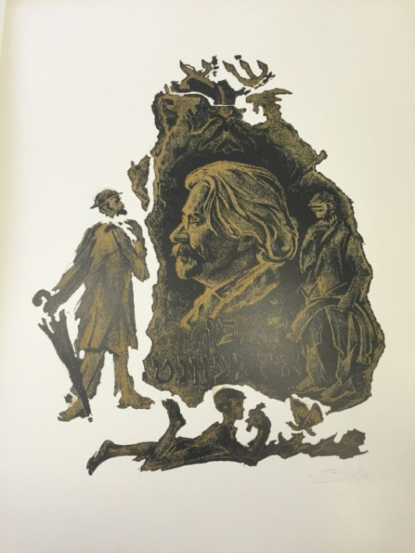
November 24, 2016 – January 22, 2017
This exhibition at the Jewish Museum and Tolerance Center is arranged to coincide with the centenary of Sholem Aleichem’s death, who is the classic author of the new Jewish literature and whose books are essential in the ‘gold reserves’ of the world culture. The photographs, biographic documents, the writer’s original manuscripts, his letters-autographs to L.N. Tolstoy and A.P. Chekhov will be displayed. Different publications of Sholem Aleichem’s pieces of writing in Yiddish translated into Russian and other languages published in different countries make a separate section of the exhibition. One will be able to get acquainted with the first rare publications of Sholem Aleichem’s books and also two volumes of published by him Jewish National Library anthology, the book which played a critical role in the making of modern literature in Yiddish.

The exhibition will present the illustrations to the writer’s books created by Nathan Altman, Mane-Katz, Anatoly Kaplan, Meyer Akselrod, Gersh Inger and other artists as well as scene designs and costumes, posters, photographs from the performances of his plays. The last section of the exhibition is dedicated to the evocation of Sholem Aleichem’s stories in cinematography. Here one will find rare posters of the 1920s-1930s and be able to watch the movie: Jewish Happiness based on the stories of Sholem Aleichem (staging by A. Granovsky, artist – N. Altman, with S. Mikhoels in the lead role). The uniqueness and content of documentary and artistic materials many of which will be exhibited for the first time make this exhibition the first in the world project which highlights the heritage of the great Jewish writer on a large scale.
The exhibition displays the exhibit items from the museums and archives of Russia: the Russian State Archive of Literature and Arts, A.A. Bakhrushin State Central Theathre Museum, the Museum of the Jewish History in Russia, the Jewish Museum and Tolerance Center and private collections.

With support of:

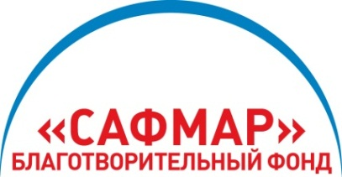
The project is realized with support of M.S. Gutseriev, businessman and founder of SAFMAR Charitable Foundation.

For your reference:
SAFMAR Charitable Foundation is among the largest non-profit charitable organizations of Russia. The Foundation was founded by AO NK RussNeft headed by Mikhail Gutseriev, the famous Russian entrepreneur and philanthropist.

SAFMAR Charitable Foundation is established to realize socially important long lasting projects in the sphere of culture, art, education and spirituality development. The Foundation program meets the criteria of transparency, precision of strategy and consistency in realization. To carry out its activities the Foundation relies on the best traditions of the Russian expertise in the sphere of philanthropy. The Foundation supports several large-scale good-will projects carried out together with many famous educational, scientific, museum and non-governmental organizations of Russia.

